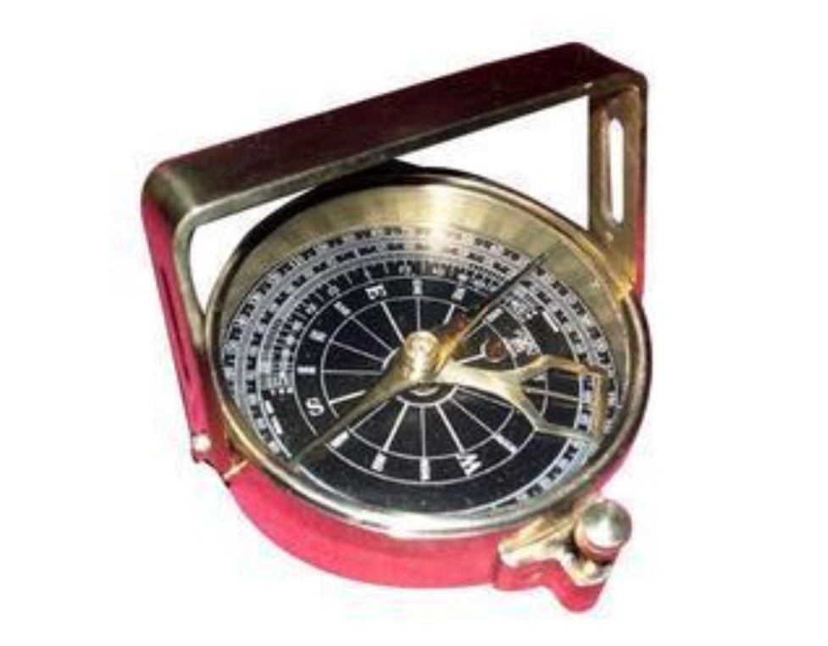

# MM Industries Clinometer Compass

| **Brand** | MM Industries |
| --- | --- |
| **Material** | Aluminium |
| **Item Weight** | 190 Grams |
| **Special Feature** | Lightweight |
| **Manufacturer** | MM Industries |

# **About this item**

* Clinometer handle compass is a reproduction of an antique clinometer compass
* The second and most interesting purpose is when tilting the compass on its side and viewing an object through the sights
* A weighted pendulous arm beneath the compass needle can be read from one of three scales like angle in degrees beneath the zenith (from straight up), angle in degrees of elevation or declination and in inches per yard of slope

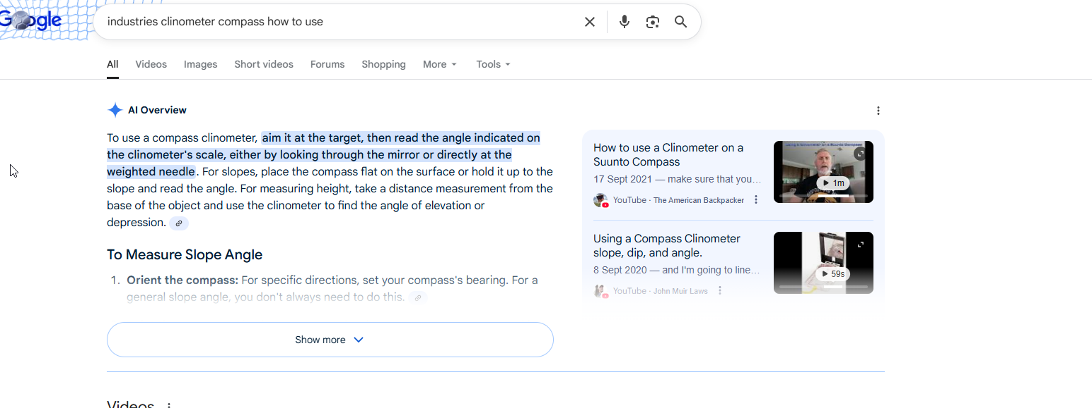

To use a compass clinometer, aim it at the target, then read the angle indicated on the clinometer's scale, either by looking through the mirror or directly at the weighted needle. For slopes, place the compass flat on the surface or hold it up to the slope and read the angle. For measuring height, take a distance measurement from the base of the object and use the clinometer to find the angle of elevation or depression.